**Advanced Analytics**

The **Advanced Analytics** phase focuses on deriving actionable insights. The aim is to perform risk scoring and segment the borrower population to identify high-risk groups.

1. **Analysis of borrower solvency**
2. **Acceptance Rate Based on Work Experience**

The acceptance rate based on work experience is an important metric for understanding how the professional background of applicants influences the likelihood of loan approval. By analysing how experience impacts loan acceptance, we can identify trends and refine lending strategies, targeting applicants with a higher chance of loan approval.

**SQL query:**

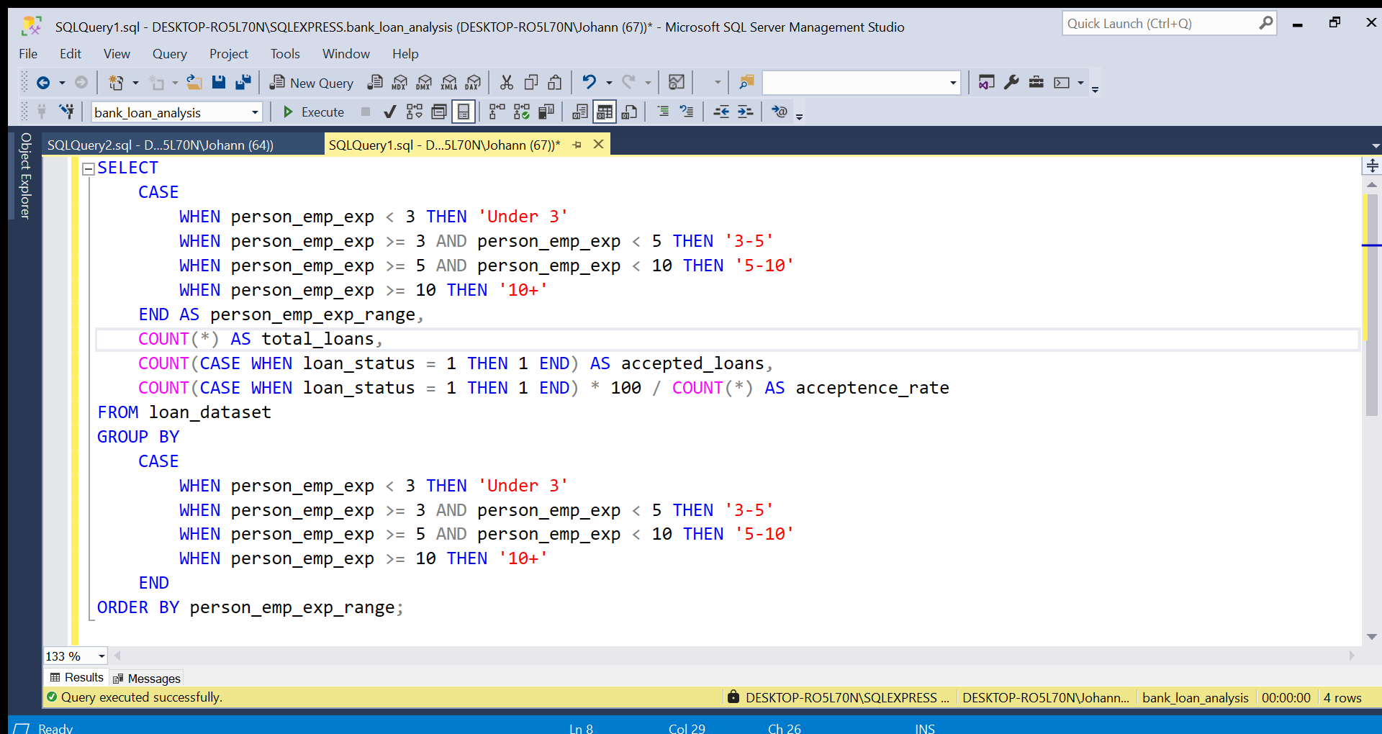

Figure 1 : Acceptance Rate Based on Work Experience

**Result:**

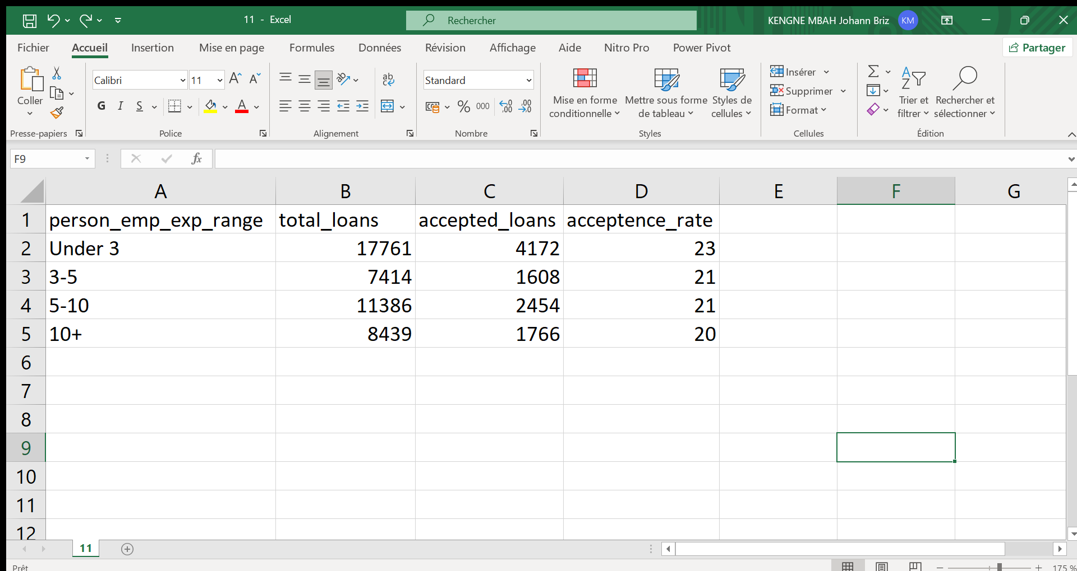

Figure 2 : Acceptance Rate Based on Work Experience Result

**Illustration:**

**Interpretation:**

From the results, we can observe that applicants with **more work experience** tend to have a higher acceptance rate.

This suggests that HSBC may favour more experienced borrowers, likely due to their higher job stability and creditworthiness. This trend could inform future loan approval criteria and help the bank optimize its risk assessment models.

1. **Home Ownership and Loan Acceptance Rate**

The relationship between home ownership and loan acceptance is essential for understanding how property ownership influences the likelihood of loan approval. Homeowners are often perceived as more financially stable and less risky by lenders, which could result in a higher rate of loan acceptance. By analysing this relationship, HSBC can adjust lending criteria to better target high-potential applicants.

**SQL query:**

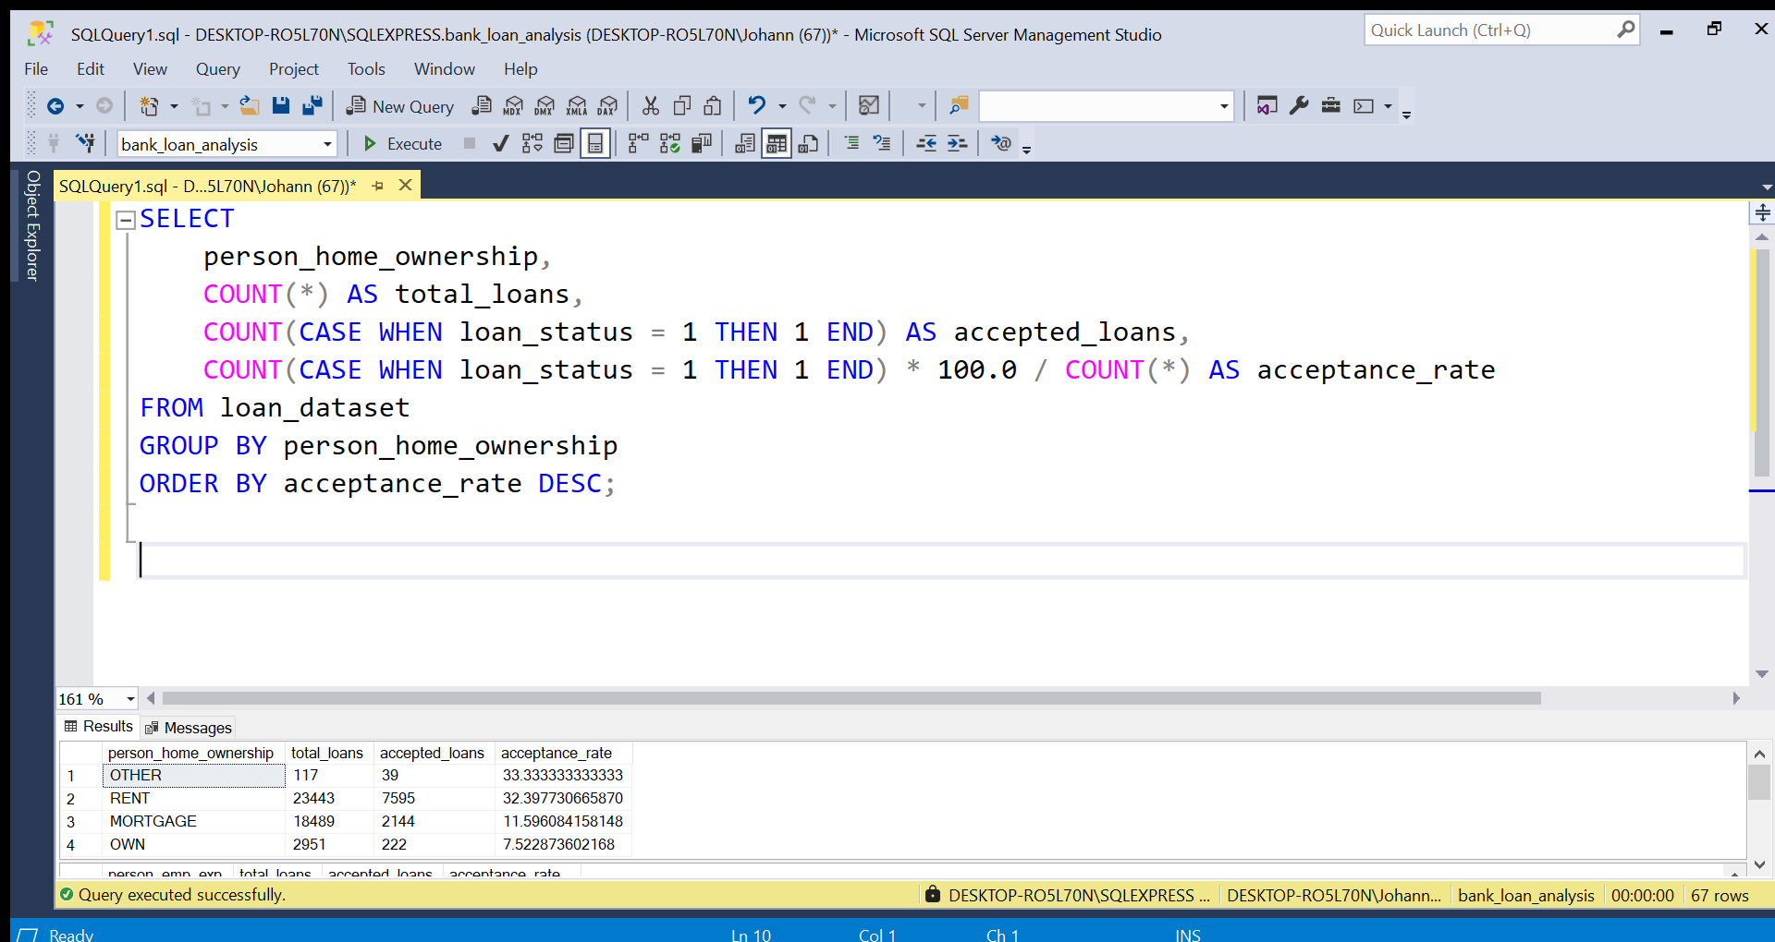

Figure 3 : Home Ownership and Loan Acceptance Rate

**Result:**

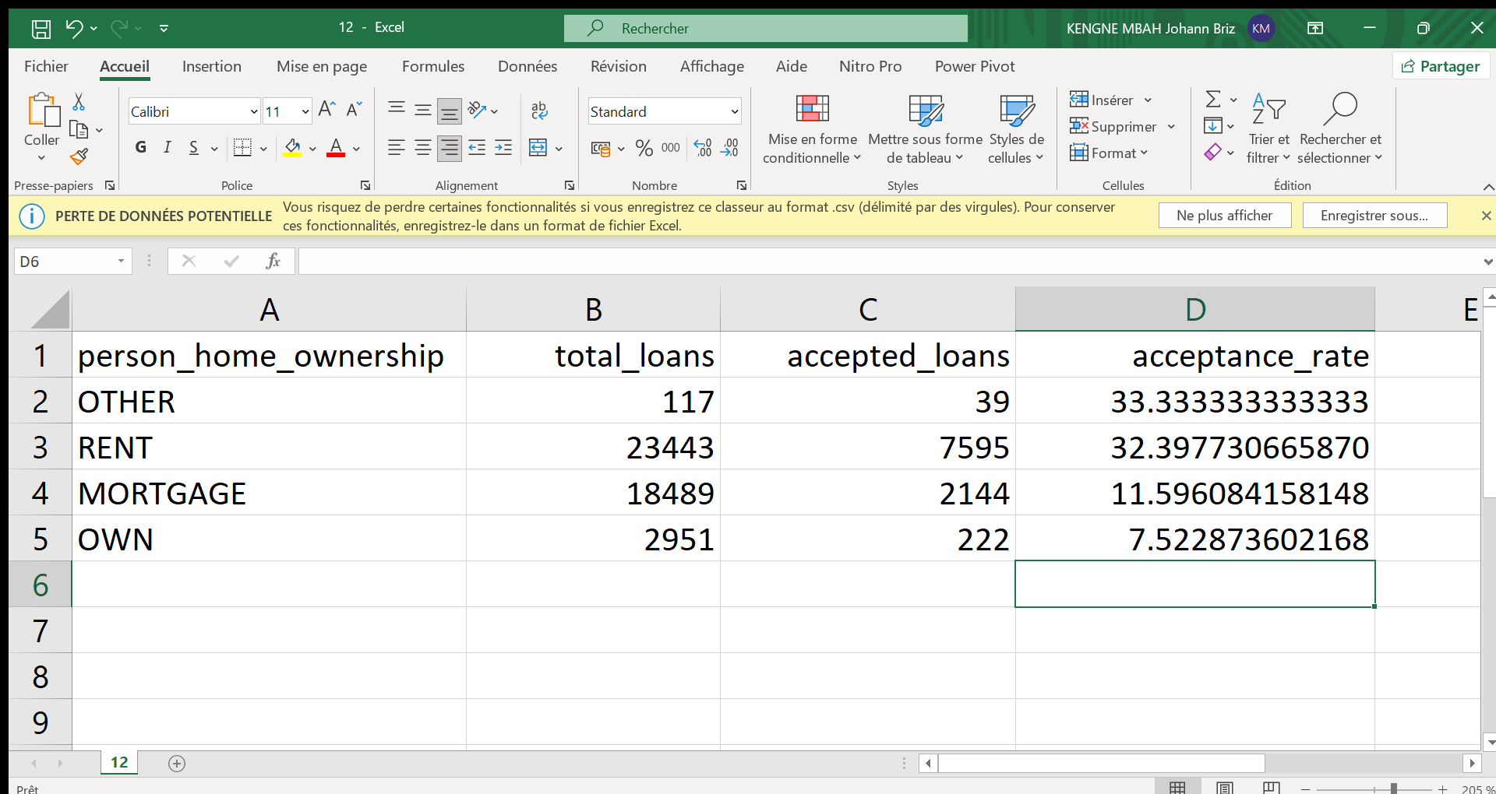

Figure 4 : Home Ownership and Loan Acceptance Rate Result

**Illustration:**

**Interpretation:**

From the results, we observe the following trends:

* **Homeowners** (those with a mortgage or owning outright) have lower acceptance rates than renters.
* **Others** (people in other living arrangements, like co-ownership or living with family) have an acceptance rate of **33.33%**, which is the highest rates.

The analysis demonstrates that **Others** **living** **is positively correlated with loan acceptance**. Own holders are the most likely to don’t have their loan applications approved, while renters tend to have a higher acceptance rate.

1. **Impact of Previous Loan Defaults on New Loan Approval**

The relationship between previous loan defaults and loan acceptance is crucial for understanding the risk associated with applicants who have a history of defaults. Borrowers who have previously defaulted on loans may be perceived as higher risk by lenders, leading to a lower acceptance rate for new loans. Analysing this relationship allows HSBC UK to better assess applicants with a history of loan defaults and refine lending criteria.

**SQL query:**

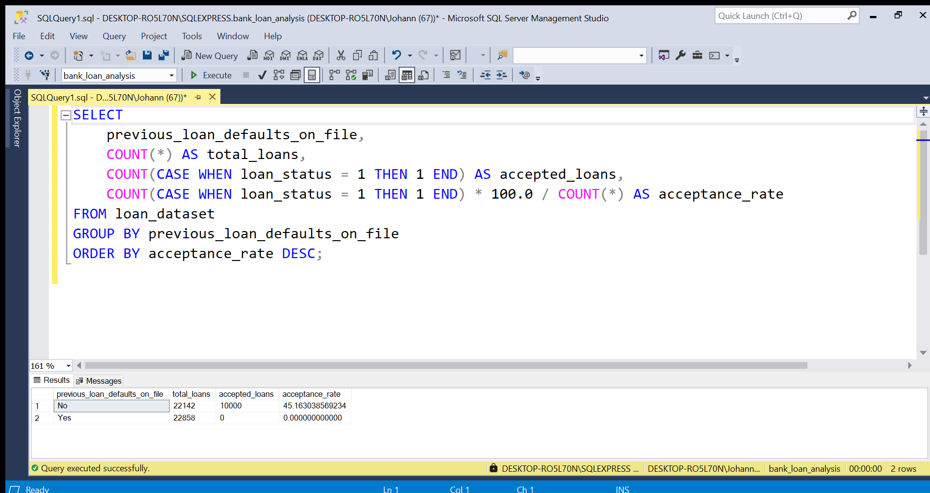

Figure 5 : Impact of Previous Loan Defaults on New Loan Approval

**Result:**

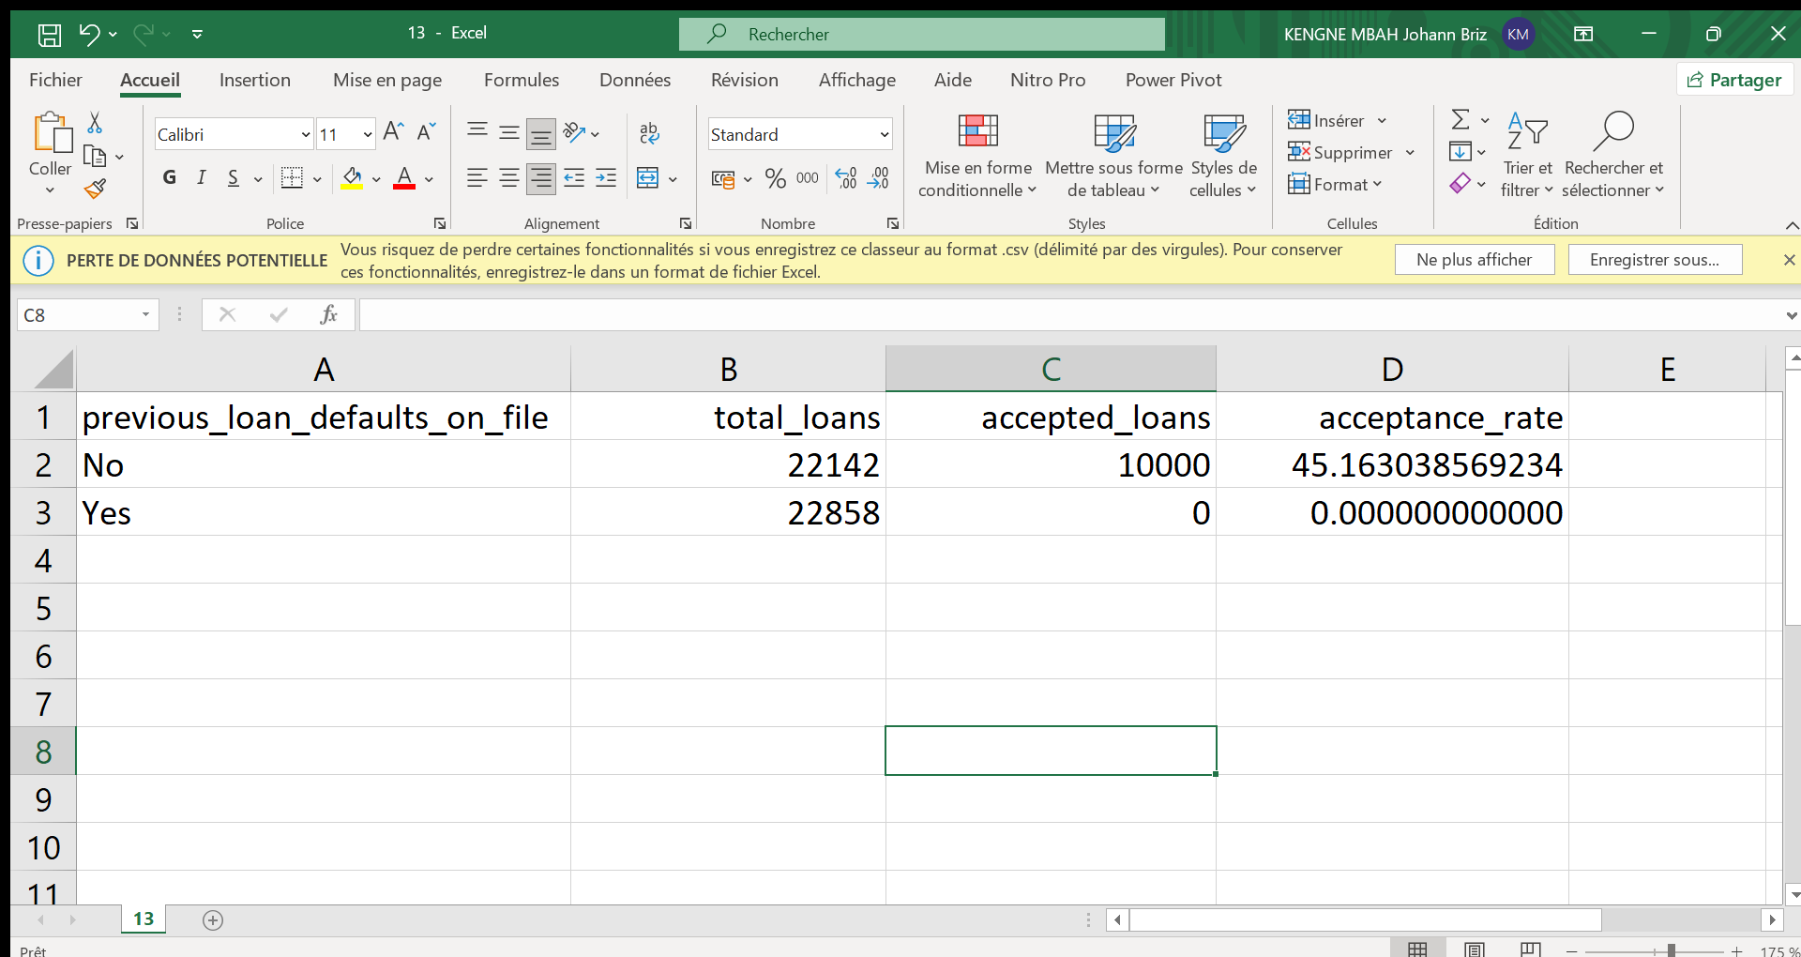

Figure 6 : Impact of Previous Loan Defaults on New Loan Approval Result

**Illustration:**

**Interpretation:**

From the results, we can make the following observations:

* **Applicants without previous loan defaults** (indicated by previous_loan_defaults_on_file = No) have a much higher acceptance rate at **45.16%**.
* **Applicants with previous loan defaults** (indicated by previous_loan_defaults_on_file = Yes) have a significantly lower acceptance rate at **0%**.

The analysis shows a clear negative correlation between previous loan defaults and loan acceptance. Borrowers with a history of loan defaults are **not likely** to have their loan applications approved compared to borrowers without such a history. This aligns with the general principle that lenders tend to view applicants with prior defaults as higher risk.

1. **Impact of Credit Score on Loan Acceptance Rate**

The credit score is a critical factor in determining the likelihood of a borrower being approved for a loan. Typically, the higher the credit score, the more likely the borrower is to be accepted for a loan, as they are considered lower risk. By analysing the relationship between credit score and loan acceptance, HSBC UK can identify the threshold at which the acceptance rate starts to decrease significantly.

**SQL query:**

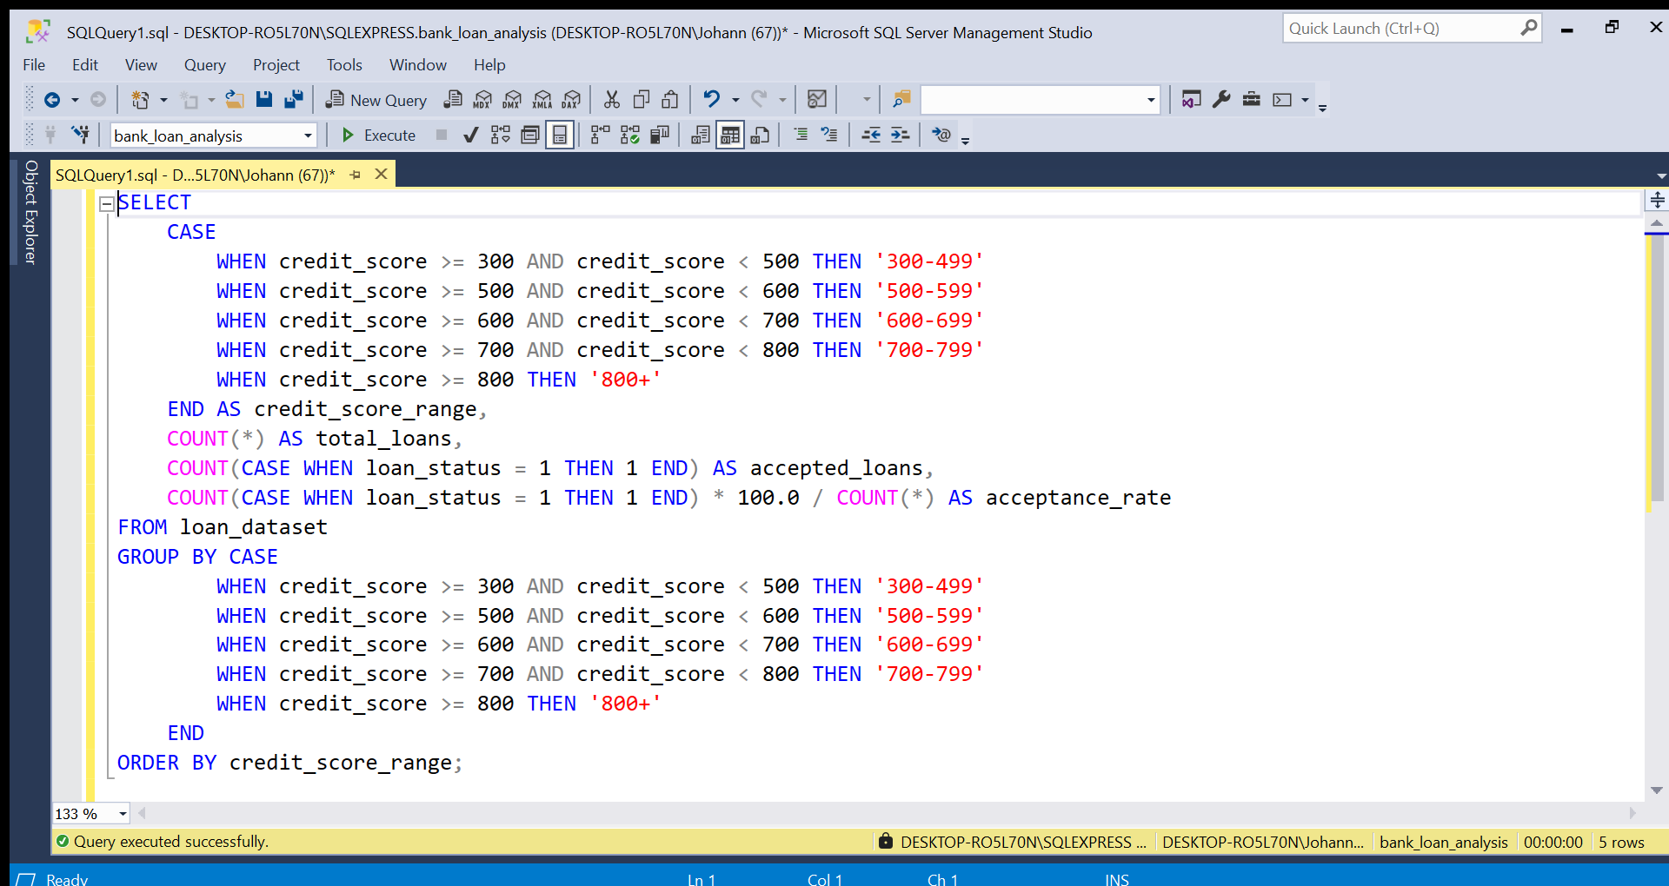

Figure 7 : Impact of Credit Score on Loan Acceptance Rate

**Result:**

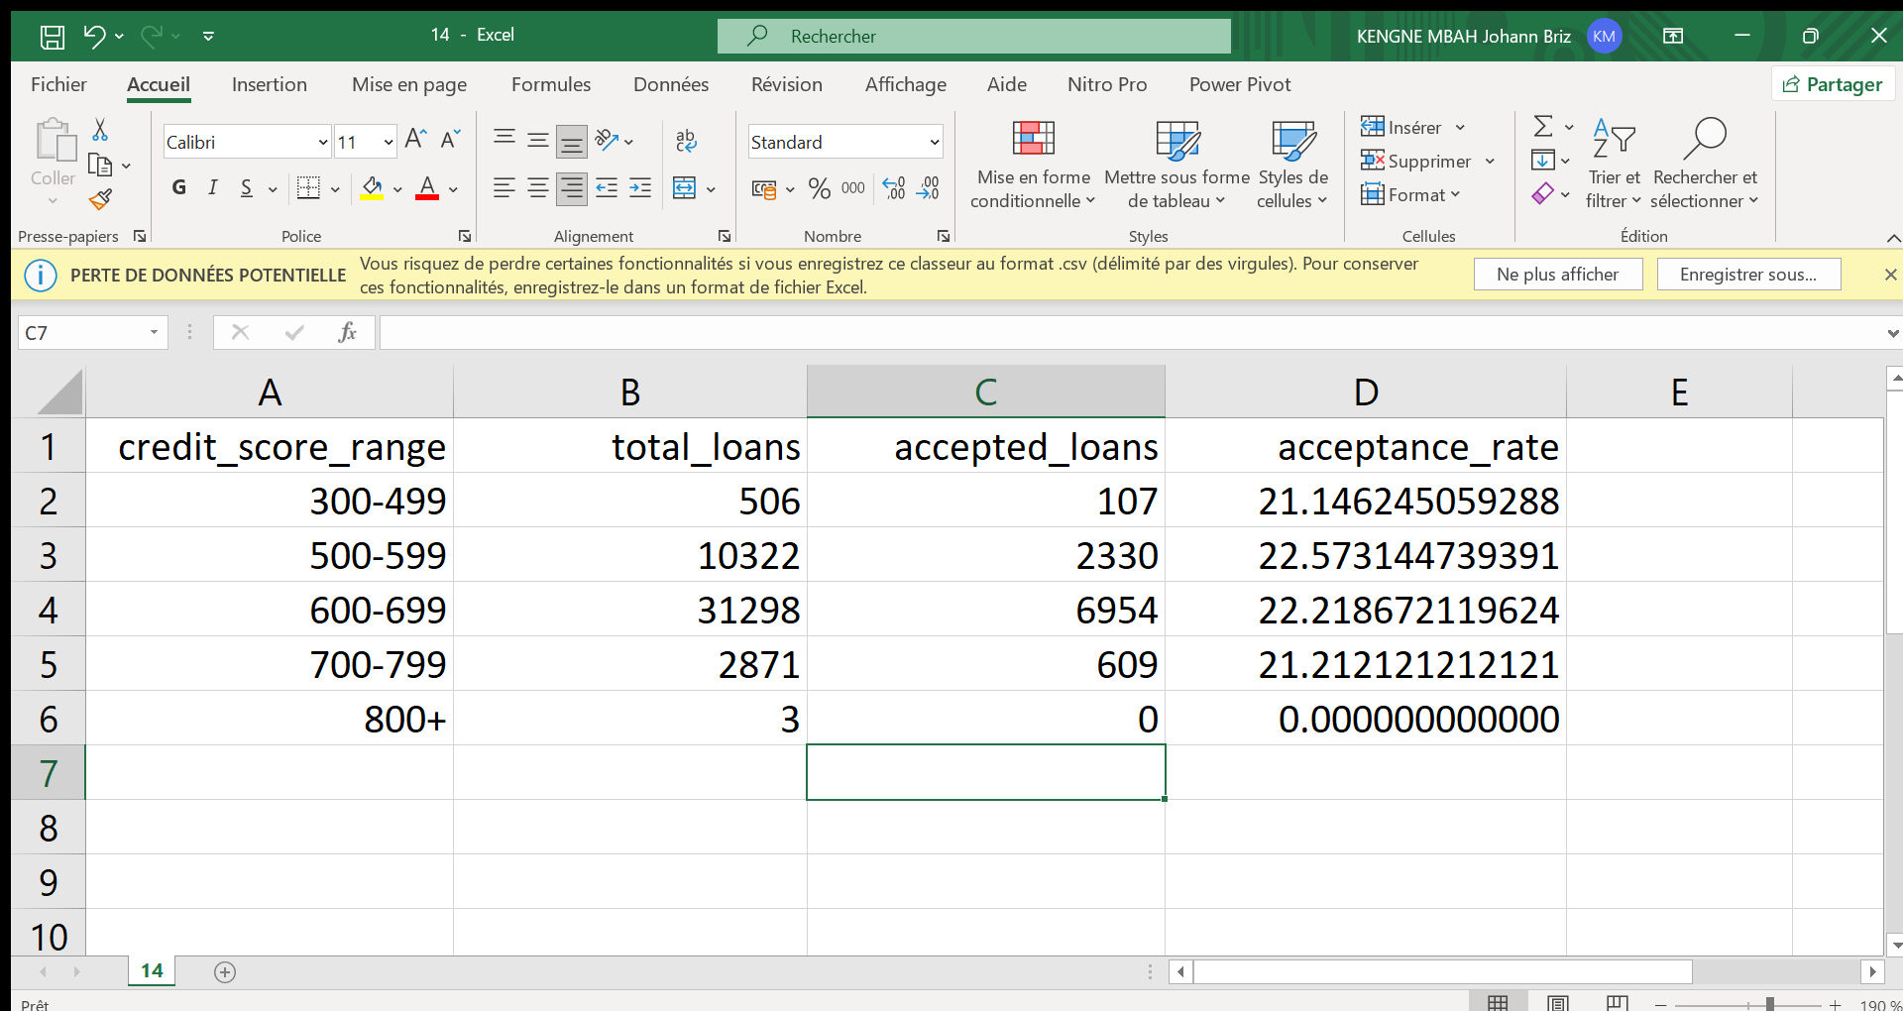

Figure 8 : Impact of Credit Score on Loan Acceptance Rate Result

**Illustration:**

**Interpretation:**

From the results, we can see that the acceptance rate is basically the same for the different ranges of credit score.

1. **Behavioural analysis and time trends**
2. **Speed of Repay Based on Borrowers Loans Amounts**

Understanding the relationship between loan size and repayment speed is crucial for assessing the effectiveness of loan terms and repayment behaviour. If smaller loans tend to be repaid more quickly, this could indicate a higher level of borrower financial stability or a less risky profile. Conversely, if larger loans tend to take longer to repay, this may suggest a greater financial burden on borrowers, leading to slower repayments.

**SQL query:**

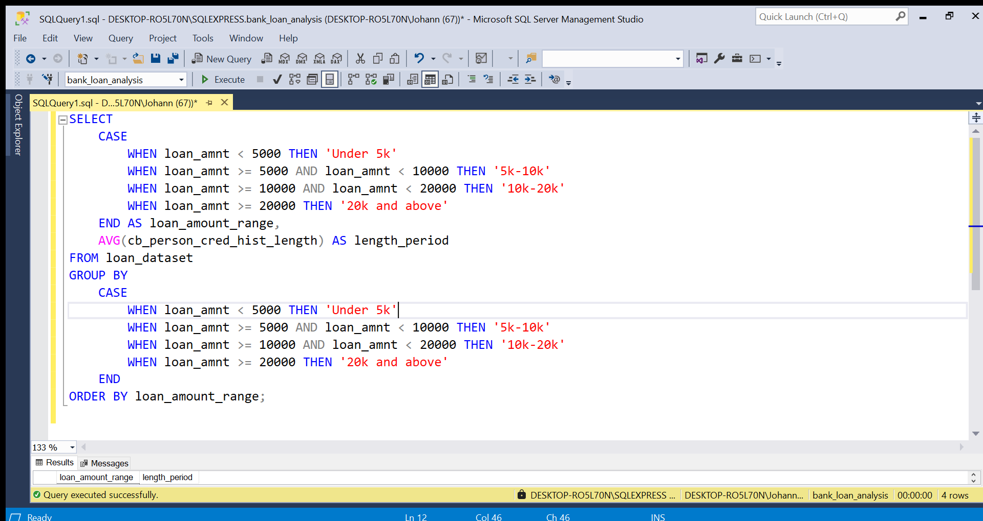

Figure 9 : Speed of Repay Based on Borrowers Loans Amounts

**Result:**



Figure 10 : Speed of Repay Based on Borrowers Loans Amounts Result

**Illustration:**

**Interpretation:**

From the results, we can say that the loan amount doesn’t really impact the duration of the payment as the durations means are practically the same for the different ranges.

1. **Distribution of Loans by Purpose (Loan Intent) and Acceptance Rate**

Understanding the distribution of loans based on the purpose of the loan and their corresponding acceptance rates is important for assessing how different loan purposes impact the likelihood of loan approval. Some loan purposes may have higher acceptance rates due to their perceived lower risk, while others, like personal loans, might be associated with higher risk and thus have lower approval rates.

**SQL query:**

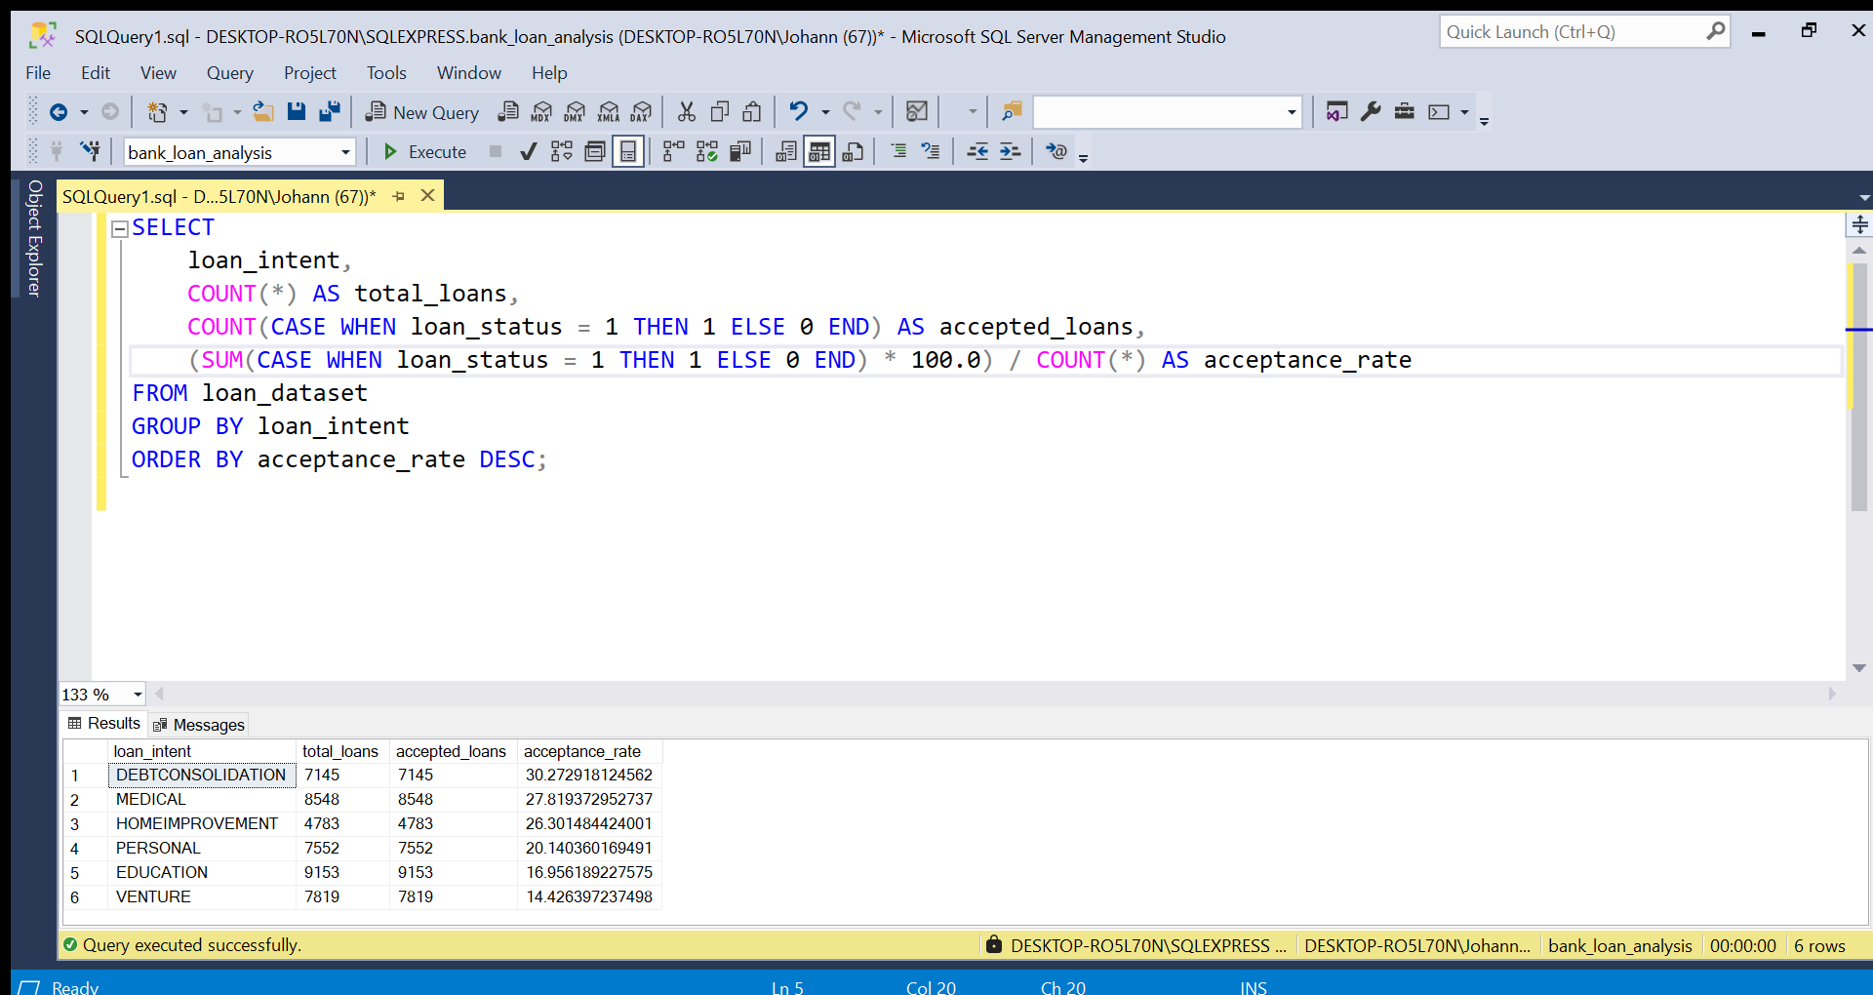

Figure 11 : Distribution of Loans by Purpose (Loan Intent) and Acceptance Rate

**Result:**

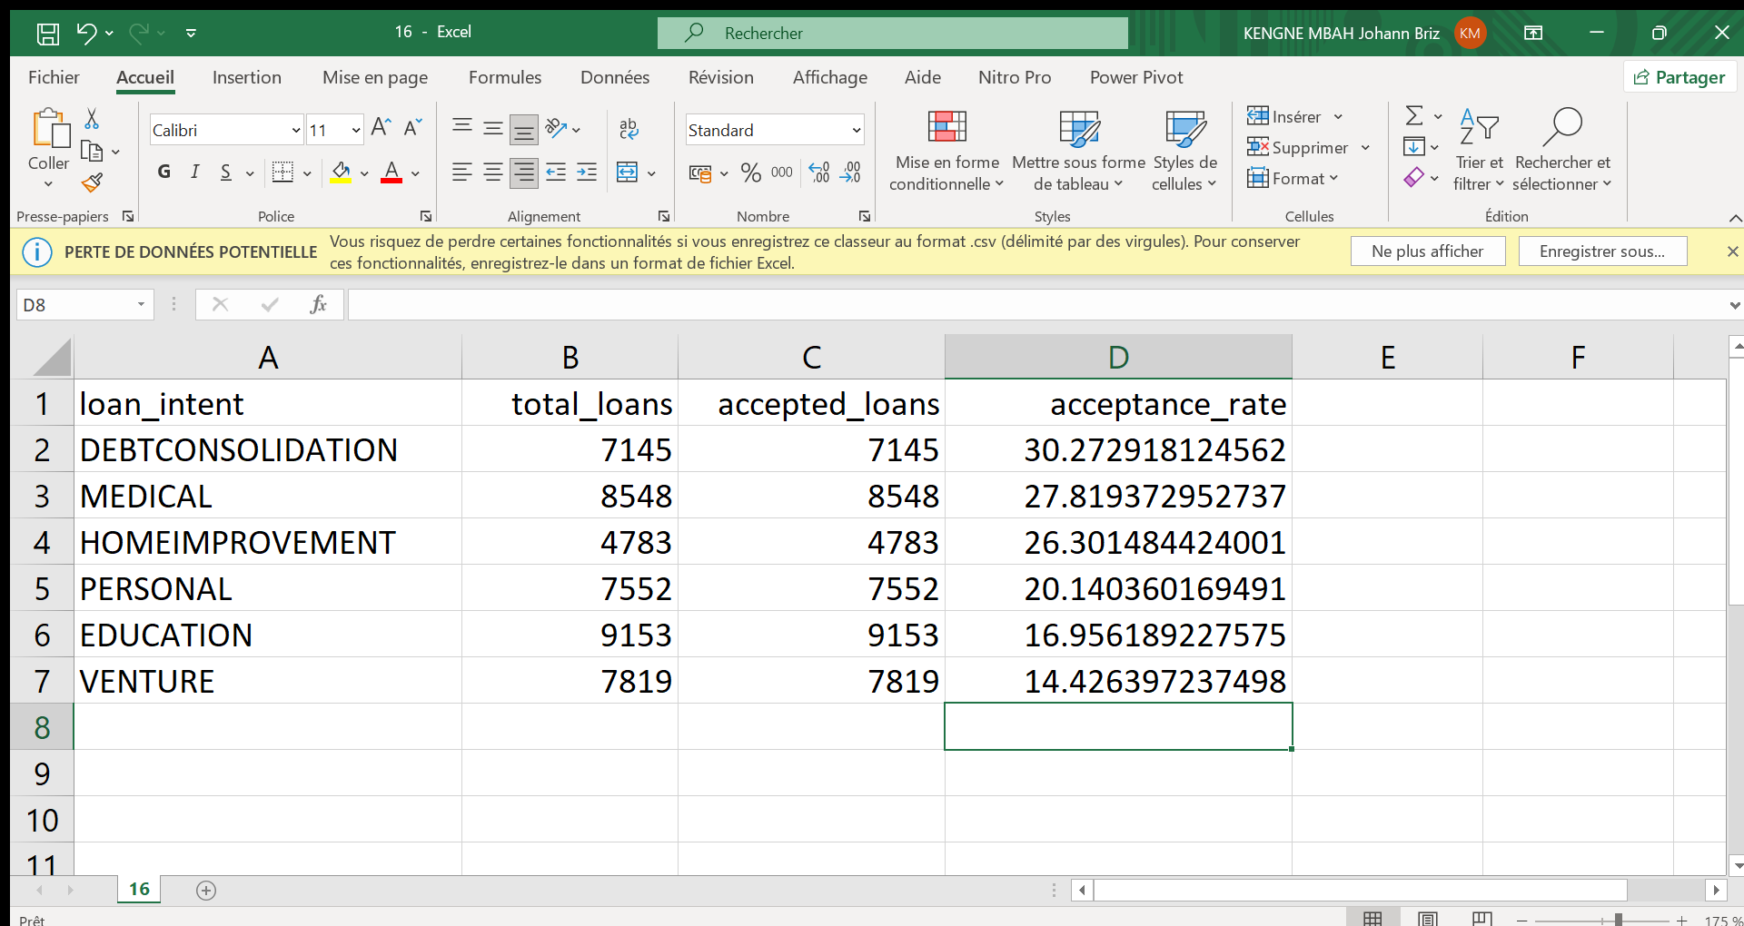

Figure 12 : Distribution of Loans by Purpose (Loan Intent) and Acceptance Rate Result

**Illustration:**

**Interpretation:**

From the analysis, we can conclude that loans for purposes such as **Debt consolidation** and **Medical** have the highest acceptance rates, while loans for more discretionary or risky purposes like **venture** tend to have lower acceptance rates.

**CONCLUSION**

Analysis of HSBC's loan acceptance criteria reveals key trends that influence lending decisions and help optimize risk management. The results suggest that HSBC could refine its risk assessment models by incorporating more nuanced criteria, particularly to better consider homeowners and borrowers with past defaults. A more balanced policy, combining preventative approaches and rehabilitation programs, would expand access to credit while maintaining a controlled level of risk.

Finally, adapting eligibility criteria based on the purpose of the loan and optimizing borrower scoring would give HSBC a better ability to target high-potential profiles, while strengthening the profitability and stability of its loan portfolio.